**Eight tips for healthy eating**

Do you remember the eight tips for healthy eating?

Fill in the blanks below and draw a picture for each tip.

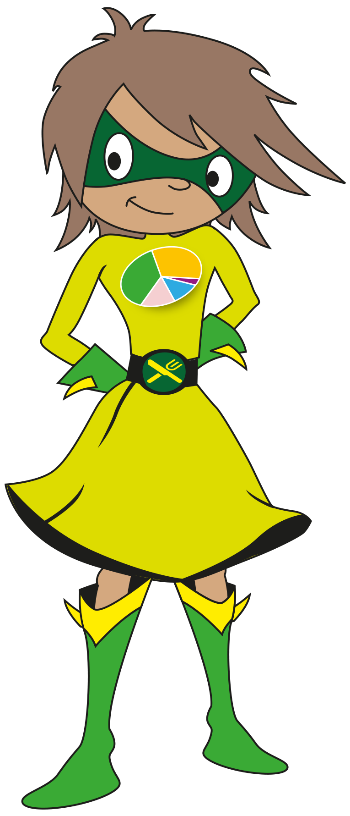

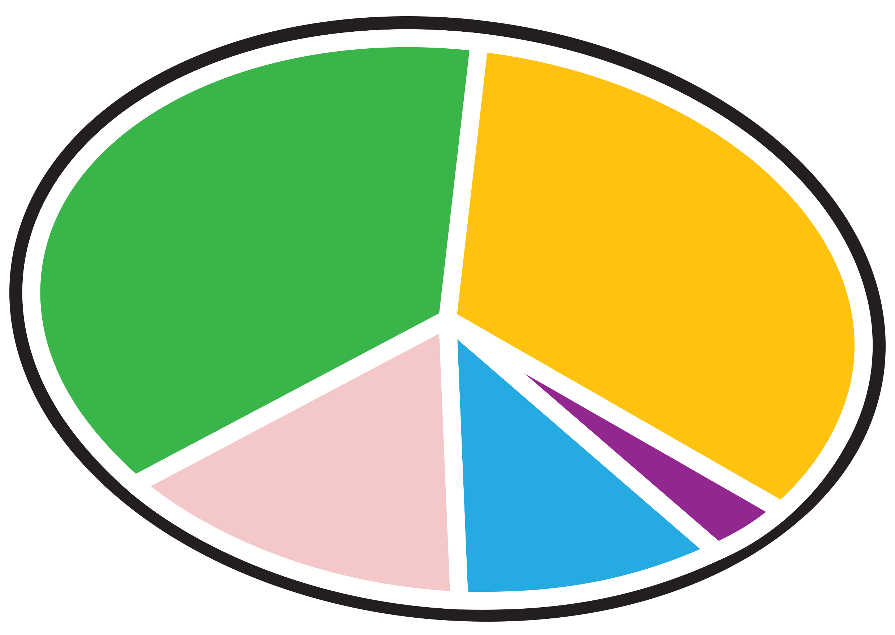

© Crown Copyright 2016