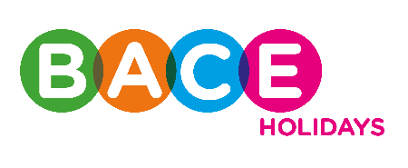

BACE Holidays – Healthy Eating Activity Evaluation Tool

Name of Activity:

Date:

What went well?
…………………………………………………………………………………………………………………………………………………………………………
…………………………………………………………………………………………………………………………………………………………………………
…………………………………………………………………………………………………………………………………………………………………………
…………………………………………………………………………………………………………………………………………………………………………
…………………………………………………………………………………………………………………………………………………………………………

What was a challenge?
…………………………………………………………………………………………………………………………………………………………………………
…………………………………………………………………………………………………………………………………………………………………………
…………………………………………………………………………………………………………………………………………………………………………
…………………………………………………………………………………………………………………………………………………………………………
…………………………………………………………………………………………………………………………………………………………………………

Key lessons learned
…………………………………………………………………………………………………………………………………………………………………………
…………………………………………………………………………………………………………………………………………………………………………
…………………………………………………………………………………………………………………………………………………………………………
…………………………………………………………………………………………………………………………………………………………………………
…………………………………………………………………………………………………………………………………………………………………………

